Name: K.Poorna chandu
Reg No: 192312585
Subject: ECA56 –5G / 6G Communication Systems

Experiment 7: Analog Beamforming Analysis Using MATLAB
Aim:
To analyze the performance of analog beamforming by studying beamforming gain, beam width, and main lobe direction using MATLAB.
Objective 1:
Program:
clc;
clear;
close all;
antennas = [2 4 8 16 32]; % Number of Antenna Elements
gain = 10*log10(antennas); % Beamforming Gain (dB)
figure
bar(antennas, gain)
grid on
xlabel('Number of Antenna Elements')
ylabel('Beamforming Gain (dB)')
title('Beamforming Gain for Different Antenna Array Sizes')
Output:
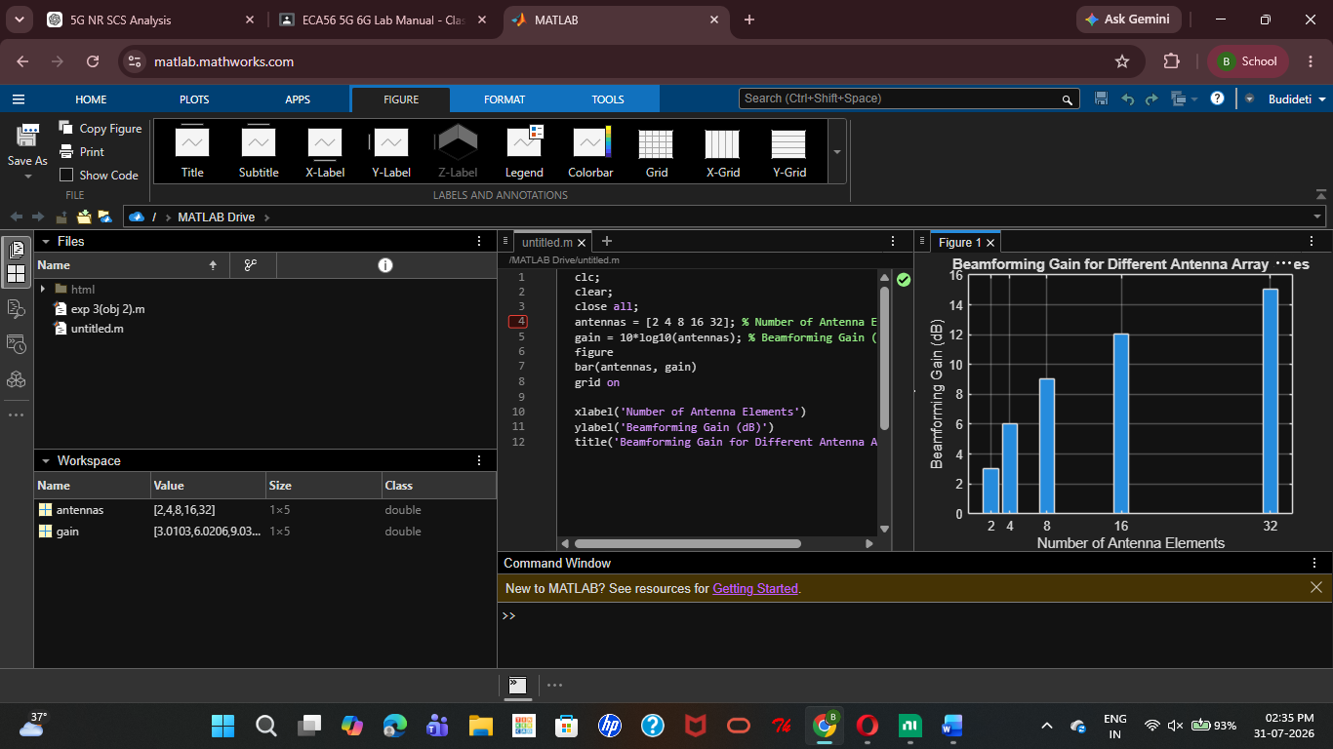

Objective 2:
Program:
clc;
clear;
close all;
antennas = [2 4 8 16 32]; % Number of Antenna Elements
beamwidth = [90 45 22.5 11.25 5.625]; % Beam Width (degrees)
figure
plot(antennas, beamwidth,'o-','LineWidth',2)
grid on
xlabel('Number of Antenna Elements')
ylabel('Beam Width (Degrees)')
title('Beam Width for Different Antenna Array Sizes')
Output:
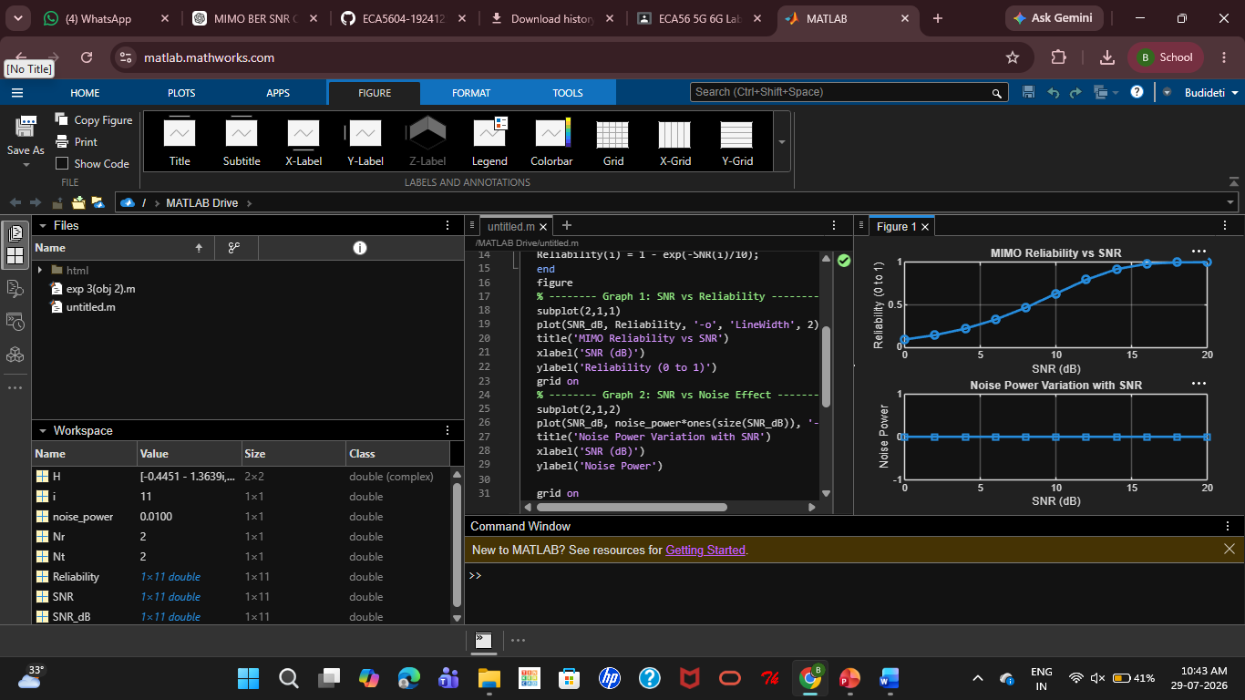

Objective 3:
MATLAB Code:
clc;
clear;
close all;
theta = [-60 -30 0 30 60]; % Main Lobe Direction (degrees)
gain = [1 1 1 1 1]; % Constant normalized gain
figure
polarplot(deg2rad(theta), gain, 'o', 'LineWidth', 2)
title('Main Lobe Direction in Analog Beamforming')
Output:
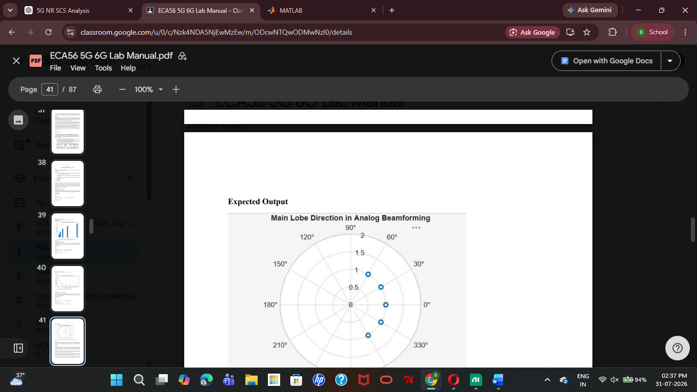
Result:
The MATLAB simulation showed that increasing the number of antenna elements improves the beamforming gain and produces a narrower beam width. It also confirmed that the main lobe can be accurately steered to different directions, demonstrating the effectiveness of analogy beamforming.

